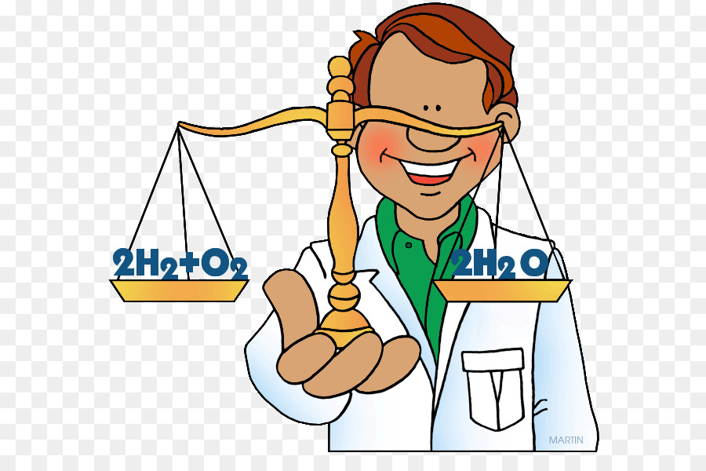 | AP Chemistry:  Proving Law of Conservation  of  Mass Lab

Purpose: Experimentally prove the law of conservation of mass for either a synthesis or decomposition reaction.

Two options:

- Synthesis of Magnesium Oxide
- Decomposition of Copper (II) carbonate

Pre-Lab- answer the following in your lab notebook
- Choose reaction to study.
- Write balanced equation for chosen reactions.
- How does this reaction work? (How do you create the necessary products?)
- What information is required to prove the Law of Conservation of Mass?
- Write a procedure to obtain information.
- Create Data Table(s)

